**DIGITAL MARKETING TOOLS FOR SOCIAL MEDIA**

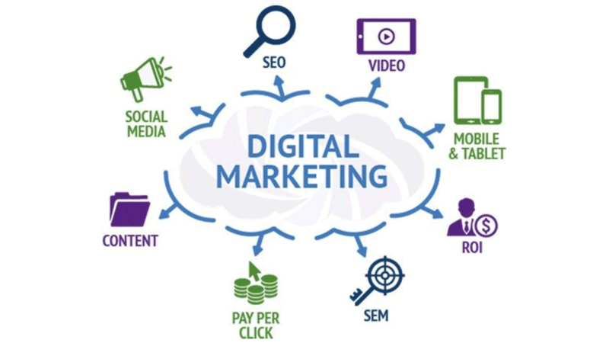In the **digital age**, social media has become an essential platform for **businesses** to reach out to their **customers.** Social media marketing allows businesses to engage with their audience, **build brand awareness,** and drive traffic to their website. To make the most of social media, businesses need to use **digital marketing** tools that can help them optimize their social media campaigns. In this article, we will **explore** some of the best digital marketing tools for social media.

1. **Hootsuite**: Hootsuite is a popular social media management tool that allows businesses to manage all their social media accounts from one place. With Hootsuite, businesses can schedule social media posts, monitor their brand mentions, and track their social media performance. Hootsuite supports all major social media platforms, including Facebook, **Twitter, LinkedIn, Instagram**, and **YouTube.**

2. **Buffer:** Buffer is another **social media management** tool that helps businesses to schedule social media posts and track their social media performance. Buffer offers a simple and intuitive interface that allows users to **schedule posts** across multiple **social media platforms.** Buffer also offers a content calendar that helps businesses to plan their social **media content** in advance.

3. **Canva:** Canva is a **graphic design** tool that allows businesses to create **eye-catching** social media graphics and images. With Canva, businesses can create **social media posts,** **banners, infographics,** and other **visual content.** Canva offers a **wide range** of templates and design elements that make it easy for businesses to create **professional-looking** graphics.

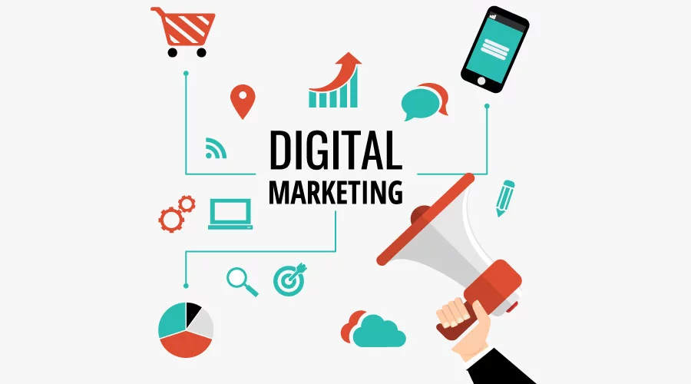4. **Sprout Social:** Sprout Social is a **social media management** and analytics tool that helps businesses to manage their social media accounts and track their **social media performance.** Sprout Social offers a range of features, including social media scheduling, social **media monitoring,** and social media analytics. Sprout Social also offers a mobile app that allows users to manage their social media accounts on the go.

5. **Google Analytics:** Google Analytics is a **web analytics** tool that helps businesses to track their website traffic and social media performance. Google Analytics allows **businesses** to track the **number of visitors** to their website, the **source of their traffic,** and the behavior of their visitors. Google Analytics also offers **social media tracking**, which allows businesses to track the number of visitors to their website who come from social media platforms.

6. **Buzzsumo:** Buzzsumo is a content research tool that allows **businesses** to find popular content in their **industry.** Buzzsumo allows businesses to search for content based on **keywords, topics**, and social media platforms. Buzzsumo also allows businesses to see who is **sharing** their **content** on social **media and track** their social media performance.

**In** **conclusion,** social media has become an essential platform for businesses to reach out to their **customers**. To make the most of social media, businesses need to use digital marketing tools that can help them optimize their social media campaigns. Some of the best digital marketing tools for social media include **Hootsuite, Buffer, Canva, Sprout Social, Google Analytics, and Buzzsumo**. By using these tools**, businesses** can **create** effective **social media campaigns** that engage with their audience and **drive traffic** to their **website.**